

Advanced Tools for fighting Online illegal trafficking

D5.6 - Data source risk assessment in the Surface Web,
Deep Web and Dark Nets

WP number and title | WP5 – Data Source and Stream Analysis
Lead Beneficiary | JADS
Contributor(s) | AIT, RISSC
Deliverable type | Report
Planned delivery date | 30/11/2019
Last Update | GG/DD/AAAA
Dissemination level | PU

Disclaimer
This document contains material, which is the copyright of certain ANITA contractors, and may not be reproduced or copied without permission. All ANITA consortium partners have agreed to the full publication of this document. The commercial use of any information contained in this document may require a license from the proprietor of that information.

The ANITA Consortium consists of the following partners:
Participant No | Participant organisation name | Short Name | Type | Country
1 | Engineering Ingegneria Informatica | ENG | IND | IT
2 | Centre for Research and Technology Hellas CERTH - ETHNIKO KENTRO EREVNAS KAI TECHNOLOGIKIS ANAPTYXIS | CERTH | RTO | GR
3 | Centro Ricerche e Studi su Sicurezza e Criminalità | RISSC | RTO | IT
4 | Expert System S.p.A. | EXPSYS | SME | IT
5 | AIT Austrian Institute of Technology GMBH | AIT | RTO | AT
6 | Fundacio Institut de BioEnginyeria de Catalunya | IBEC | RTO | ES
7 | Istituto Italiano per la Privacy | IIP | NPO | IT
8 | SYSTRAN SA | SYSTRAN | SME | FR
9 | Stichting Katholieke Universiteit Brabant | TIU-JADS | RTO | NL
10 | Dutch Institute for Technology, Safety & Security | DITSS | NPO | NL
11 | VIAS Institute | VIAS | RTO | BE
Law Enforcement Agencies (LEAs)
12 | Provincial Police Headquarters in Gdansk | KWPG | USER | PL
13 | Academy of Criminalistic and Police Studies – Kriminalisticko-Policijska Akademija | AoC | USER | RS
14 | Home Office CAST | CAST | USER | UK
15 | National Police of the Netherlands | NPN | USER | NL
16 | General Directorate Combating Organized Crime, Ministry of Interior | GDCOC | USER | BG
17 | Local Police Voorkempen | LPV | USER | BE

To the knowledge of the authors, no classified information is included in this deliverable
Document History

VERSION | DATE | STATUS | AUTHORS, REVIEWER | DESCRIPTION
V0.1 | 18/09/2019 | ToC | JADS | Table of Content
V0.2 | 19/09/2019 | ToC | JADS | Refined Table of Content from WPL Feedback
V0.3 | GG/DD/AAAA | Final Draft | JADS | Final Draft ready for Review

Definitions, Acronyms and Abbreviations

ACRONYMS / ABBREVIATIONS | DESCRIPTION
LEAs | law-enforcement agencies
DDoS | distributed denial-of-service
MITM | man-in-the-middle
URL | Uniform Resource Locator
UNODC | United Nations Office on Drugs and Crime
ICS | industrial control systems
DNS | Domain Name System
MRQ | Main Research Question
SRQ | Sub-Research Question
LDA | Latent Dirichlet Allocation
UML | Unified Modeling Language
GLBA | Gramm-Leach-Bliley
FCRA | Fair Credit Reporting Act
GDPR | General Data Protection Regulation
SDN | software-defined networks
VNF | virtual-networks functions
SYN flood | half open attack
UDP | User Datagram Protocol
LDA | Latent Dirichlet Allocation
SMB | Server Message Block
CSIRT | Computer Security Incident Response Teams
OSN | Online Social Networks
IODEF | Incident Object Description Exchange Format
CTI | Cyber Threat Intelligence
OTX | Open Threat Exchange
GLBA | Gramm-Leach-Bliley Act
ACP | Anonymous Crawling Policies
SQUAL | Software Quality
WSAP | WebSite Appearance Parameter
METH | Methods for the risk assessment
SRLP | Source Risk-Level Parameter
DEPTH | Depth of Analysis
CTYPE | Type of criminal activity
CMEASURE | Countermeasure
PICO | Population, Intervention, Comparison, Outcome

Table of Contents
Document History 3
Definitions, Acronyms and Abbreviations 4
Table of Contents 5
List of Figures 6
List of Tables 7
Executive Summary 8
1 Introduction 9
1 Background 10
1.1 ANITA Use Cases Overview and Terms and Definitions 10
1.2 Overview of Task 5.1 10
1.3 Scope of the Deliverable and Objectives 10
2 Research Design and Research Questions 11
3 Research Materials and Methods 12
3.1 Overview of the used web-surveys and the focus-groups 12
3.2 Discussion of the Inter-rater Reliability Assessment 12
4 Discussions and Implications 13
4.1 General Implications for ANITA project 13
4.2 Module’s Implications for ANITA project 13
5 Conclusions 14
5.1 Gap and Future Work 14

List of Figures
Figure 1 Information collected during an attack 13
Figure 2 Mathematician formula for SUPPORT 13
Figure 3 Mathematician formula for CONFIDENCE 13
Figure 4 Mathematician formula for LIFT 14

List of Tables
Table 1 Attack type and number of user affected 12

Executive Summary
Task 5.1 investigates what are the techniques and indicators to perform cybercrime detection and threat intelligence over multiple analysis levels (i.e., surface, deep, and darknet), moreover the state of the art in such techniques has been systematically analysed. Task 5.6 it is an updated and revised version of task 5.1 that investigates the correspondence of the techniques and indicators in a real-life scenario. For this purpose, a mixed-methods research approach featuring (1) confirmatory semi-structured interviews with Law-Enforcement Agencies (LEAs) as well as (2) a confirmatory larger-scale web-survey fed to the most accurate sources (e.g., LEA networks of excellence such as ENLETS) and (3) a compendium of machine-intelligence techniques comprehensive of topic modelling as well as association-rule mining has been used in order to elicit the most appropriate best-practices submitted to practitioner and professionals from the industrial environment. The best practices were elicited by confirmation of best practices, taxonomies, concepts, and theories previously illustrated in the scope of D5.1, as well as several additions, for example, the personal and professional parameters which need further protection to ensure online anonymous crawling.

Introduction
Significant cybersecurity and threat intelligence analysts agree that online criminal activity is increasing exponentially. In order to offer an overview of the techniques and indicators to perform cybercrime detection and threat intelligence over multiple analysis levels (i.e., surface, deep, and darknet), Task 5.1 analysed state of the art and systematically analysed the available techniques. What has been found from Task 5.1 is what online depth levels are assessed and to what extent, what degrees of anonymity exists for web-crawling, what policies exist to vary the degrees of anonymity, what website features are most indicative of cyberthreats and what risk assessment techniques exist.
The review concludes that there is a gap between the grey literature and the white research literature. The first mainly focuses on reported vulnerabilities, and the latter offers a solution to predict, avoid, and protect against specific cybercriminal attacks. The second finding from the Task 5.1 is that no single community encapsulates cybercrime-fighting software, tools, approaches, and techniques. Lastly, there is no one definitive solution towards assisting law-enforcement agencies in their cybercrime fighting activity.
The deliverable from Task 5.6 is in charge of building a confirmatory (or a refusal) overview of our previous study about the taxonomy for surface, deep, and dark web discussed in Task 5.1. The taxonomy presented in Task 5.1 regards the risk assessment methods available, countermeasure against cybercriminal activities, anonymous crawling policies and the possibility to stay anonymous while performing cybercrime detection, risk-level parameters, software quality parameters to understand if an online source bears risk of cybercriminal activity, website-appearance parameters to look for those indicators of cybercriminal activity, criminal activity type to know what type of cybercrimes are perpetrated online. In order to assess Task 5.1, two types of questionnaire have been developed. A semi-structured interview where open questions where submitted to practitioners and LEAs (Law Enforcement Agencies) and a Likert Scale questionnaire submitted to LEAs where they had to agree or disagree (from 0 I strongly disagree to 5 I strongly agree) to some statements and finding extrapolated from Task 5.1.
The results provided in this deliverable are an overview of if all the topics, approaches, indicators, risks, fallacies, and pitfalls found in Task 5.1 are effectively used and useful for LEAs in order to recognize, avoid, fight and prevent cybercrimes. The aim of Task 5.6 is, indeed, to have a countercheck of what has been found in Task 5.1 from the “real world”.
The rest of this survey is organized as follow. In paragraph Background is depicted an overview of the ANITA Use Cases and the results from Task 5.1. Meanwhile, in paragraph Error: Reference source not found are presented, explained and discussed the questions submitted to the LEAs. In paragraph Research is given an overview of the questionnaire used for the research and the methods adopted. Paragraph Discussions and Implications flashes out the implications for the ANITA project and the meaning that the results have in the contest of ANITA. Lastly, in paragraph Conclusions are discussed the results and presented the future works.

Background
According to the knowledge of the authors, Task 5.1 represents the first systematic literature review providing a taxonomy about the different type of cybercrime and threat intelligence solutions. However, as often happens, the academic environment is sometimes far from the real world and its problems. In order to fill this gap has been decided to further investigate the different type of threat intelligence solutions and find a further confirmation from the LEAs environment. In the online literature, there are no surveys trying to create a general overview of the cybersecurity risks and the proposed solutions in order to contain the risks, it is then important to have Task 5.6 to bring the point of view of LEAs and their knowledge in order to fill the gap among academic and the so called real world.

ANITA Use Cases Overview, Terms, Definitions
In the following is described each use case scenario from the ANITA project. The project defines three use case scenarios listed below:
- Use case 1: Counterfeit/falsified medicine, drugs, and NPS
- Use case 2: Weapons and Firearms trafficking
- Use case 3: Terrorism Funding

Counterfeit/falsified medicine, drugs and NPS: predictably, counterfeit goods have a huge place in the criminal economy of the Dark Web. From clothing to cosmetics and counterfeit medicines all things are for sale in this landscape without rules. In 2011 the World Economic Forum reported that illicit goods trade was thought to represent 7 - 10% of the global economy (Forum, 2011). It has been approximated that 10% of drugs sold worldwide are counterfeit, with the prevalence of these drugs in certain areas of Africa and Asia believing to have reached 70% (Liang, 2005, Clark, 2015). It is then evident how counterfeit medicine is bringing much more profits than any other classic illicit drug. Moreover, the market of counterfeit medicine produces a business of $200 billion per year and this number is likely to continue to grow.
Weapons and Firearms trafficking: The Dark Web is a huge place where illegal trades can take place being safe from the eyes of the law. In 2016 in Munich a so called lone-wolf terrorist decided to use a weapon purchased on the dark web in order to kill nine people. Moreover, police believed it was an older weapon that had been reassembled and was still working to establish where the attacker had obtained the 300 rounds of ammunition found in his rucksack (Hume, 2016; Munich gunman planned attacks for one year: officials, 2016). In 2013 has been estimated global trade arms of $76 billion while international domestic military expenditures were $1.7 trillion (Dr Aude Fleurant, 2016). There are different channels legal and less legal where firearms are sold, between 30% and 40% of all firearm sales in the US occur in the secondary market. Among all these legal and less legal markets, we have also the Dark Web markets where (Giacomo Persi Paoli, 2017) estimated firearm transactions on dark web forums be around 136 sales per month. Moreover, in (Robitzski, 2019) we have that most of the gun sold are for handguns and only four percent were for military-grade, automatic weapons. However, the ease of buying firearms on the Dark Web is not the only concern. Even if a user does not have enough money to afford a proper gun from the dark webmarket, the Dark Web itself is full of documents, manuals, guidelines, forums and book on how to convert a prop gun into a real gun. In (Giacomo Persi Paoli, 2017) is explained how the Dark Web can provide all the information on how to build or print all the parts in order to build an untraceable gun.
Terrorism Funding: Since it first came into existence in 2009, Bitcoin has been causing controversy, confusion, and consternation in equal measure. The cryptocurrency at the date of today, 25th of June 2019 is valued at 1 bitcoin to $11.300.90. However, what exactly is a bitcoin? “Bitcoin is a cryptocurrency, a form of electronic cash. It is a decentralized digital currency without a central bank or single administrator that can be sent from user to user on the peer-to-peer bitcoin network without the need for intermediaries”. Another good question could be: is bitcoin anonymous? Not entirely. Every bitcoin transaction is publicly broadcasted on the Bitcoin blockchain. Because all transactions are permanent and public, a massive map is being created as time goes on that allows simple analytical tools to paint a picture of where bitcoins are going. Bitcoin addresses are “anonymous,” but if an address can somehow be linked to a real-world identity, Bitcoin offers no privacy. There are a number of ways to connect addresses to real-world identities, most notably via KYC/AML (Know Your Customer/Anti-Money Laundering) policies at exchanges and blockchain analysis (e.g., address clustering) (Magazine, 2019). However, there are methods and techniques in order to keep the anonymity of bitcoin transactions. Some of these techniques are the bitcoin mixing that is a process to break the linkability or traceability. The use of Tor-onion routers in order to stay anonymous and protect personal IP. The use of VPN (Virtual Private Network), the use of new address for each bitcoin transaction that means you can generate any number of receiving address & every time you receive bitcoins from anywhere, use a new address. Buy or sell bitcoins in cash.

Use-Cases overview in the context of Task 5.1
In today’s world, cybersecurity is becoming increasingly important for businesses and individuals alike. Carrying out cyberattacks is now a lucrative career aided by the development of marketplaces within the Dark Web allowing for complete anonymity. In this area if the World Wide Web, anyone from enthusiasts to professionals have the ability control of company information from anywhere in the world. Whether used to manipulative sites, hold company servers for ransom, or gather large amounts of personal data, tare an unforeseen threats that businesses today must learn to account for.
In order to give an overview of the use cases discussed above in the context of Task 5.1, has been decided to build a dataset of data breaches. Data collected for this research was collected using breach sites and services such as cybersecurity speaker Troy Hunt. This was used in order to compile a list of data breaches, using data collected since 2012 in order to show the data most relevant and applicable to current conditions of the Internet.
The six most common attacks identified were SQL Injection, Malware, Phishing, Man in the Middle, Cross Site Scripting, and internal breach. From this research has been noticed that Man in the Middle attacks had the highest median number of individuals affected, making it an effective strategy for illicit gathering of data. However, MitM attacks also had the largest interquartile range of all the different types of attacks, making this not only a profitable method of attack, but also one effective in a variety of breaches, making this a threat to businesses of all sizes.
Attack Type | Malware | MitM | Phishing | XSS | Internal | SQL Injection | Credential Stuffing
Median Individuals Affected | 648,231 | 4,789,599 | 504,565 | 3,619,948 | 252,483.5 | 709,926 | 1,749,806
IQR | 2,273,754 | 52,374,128.5 | 426,804 | 3,035,788.75 | 16,842,337.5 | 4,880,272 | 7,738,958
Table 1 Attack type and number of user affected
When looking at the data collected, the most common piece of personal information collected was email addresses.
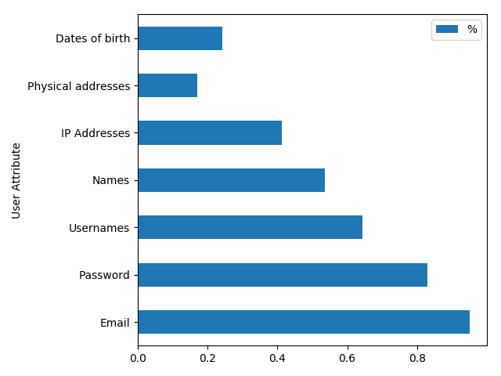
Figure 1 Information collected during an attack

On the data collected has been decided to apply Association Rule Mining via Apriori Algorithm in order to identify relations between our attacks and the data retrieved by the attack itself. Association rule learning is a rule-based machine learning method for discovering relations among variables in a big database. It identifies the most recurrent if-then associations called association rules which consists of an antecedent (if) and a consequent (then). In order to measure the association exists three common metrics ('Yosola, 2018).
- Support indicates how frequently a specific item appear in the data. Is represented by the mathematician formula below.
Figure 2 Mathematician formula for SUPPORT

- Confidence indicates how many times the statement if-then is found as true. Is represented by the mathematician formula below.
Figure 3 Mathematician formula for CONFIDENCE

- Lift it is used in order to compare the confidence with the expected confidence. It indicates the likeliness of item Y when purchased when X is purchased. Mathematically
Figure 4 Mathematician formula for LIFT

The dataset used is composed of all perpetrated attacks and the type of personal data retrieved after the attack. On the dataset has been then applied Association Rule Mining in order to understand a connection among the attacks and the data retrieved. Hence, with the results from the machine learner, try to build a lesson learned and give some important advices in order to protect personal data online.

Terms & Definitions

Background: an Overview of Task 5.1 Results and State of the Art

Scope of the Deliverable and Objectives
The scope of this deliverable encompasses the applicability of the literature-elicited definition of methods and indicators for the risk assessment of new data sources. According to the task description the concept of risk-level, as previously specified, is referred to different aspects strictly connected: on one hand, the risk level is due to the involvement of source in illegal trafficking activities; on the other hand, the possibility that criminal groups that own or manage sources monitored by LEAs could recognize anomalous activities due to the crawling process and block them, compromising the investigations. The best-practices and concepts previously showcased in D5.1 have taken into account that risk level of a source can increase with its depth in the web whereas the presented methods dictate what metadata that can be extracted (e.g., websites appearance, their update frequency and refresh in data to be taken into account during the assessment stage) in order to define which policies should be enabled to perform the crawling and with which degree of anonymity. With the aforementioned scope in mind, this deliverable and the work recapped herein have the following general objectives:
- To confirm the applicability and usefulness of what previously reported in the scope of D5.1;
- To compound what was previously reported with ancillary quantitative analysis where required;
- To offer a final overview over which best practices are best fit with the foreseen ANITA use-cases.
The rest of this document fleshes out the aforementioned general objectives into appropriate research questions, elaborating on the research methods we adopted to attain the results necessary to pursue said objectives.

Research Design
This section fleshes out the research questions, materials, and methods we harnessed to attain the necessary research results pursued by the objectives highlighted in Sec. 1.3 from the previous Section.

Research Questions
Stemming from the aforementioned goals, we formulated the following research questions.
- Do ANITA Practitioners perceive the veracity of D5.1 indicators elicited from the state of the art?
- Do ANITA Practitioners use other previously-unmentioned indicators?
- What is the coverage of the ANITA practitioners expertise and intended use-cases?
- To what extent does the specialised public at large agree with D5.1 concepts and indicators?
- To what extent does the specialised public agree with the ANITA practitioners knowledge and expertise?
- Does quantitative analysis of open-source intelligence reveal additional best-practices to compound D5.1?

Semi-structured interviews
We interviewed 7 professional Law-Enforcement agents from the ANITA use-case base. The law-enforcement agents are actively pursuing online illicit activity investigations and are actively engaged both in the ANITA project as well as the use-case definition activities envisioned in the project. The focus of the interview was to make participants discuss their good and bad practices in each of the indicator areas elicited as part of D5.1. Before each interview, we informed the participants about the goals of this study and the fact that all collected data would be used for research purposes and reporting in the scope of ANITA itself. Participants were also informed that they could end the interview at any time. All interviewees were developers or technical leaders. Interviews were conducted by two of the authors, and took 4:30 hours in total. Interviews were transcribed automatically using an online form used interactively with the practitioners at hand and focused on the specific use-cases reported under use by the practitioners themselves. The data stemming from this process is illustrated further in the scope of Sec. 2.6.

Large-Scale Web Survey
We designed a survey aimed at investigating good and bad practices related to the indicators stemming from D5.1 – more specifically, the questions contained in the survey were designed to cover completely the indicators elicited as part of the literature review work conducted and reported in the aforementioned deliverable and for the purpose of confirming the practical validity of the reported indicators. We asked participants about good and bad practices they perceive for playing each of the roles and using each of the indicator areas reported in D5.1. In order to recruit participants, we sent invitations to a total of 61 practitioners who had at least recent experience (< 3 months) with the subjects covered by our survey; the pool of practitioners to which the survey was submitted corresponds to the ENLETS network of excellence on law-enforcement technology as well as the OASIS Open Standards Committee on Cyber-Threat Intelligence. Quoting from their own standardization website, “the OASIS Cyber Threat Intelligence (CTI) TC was chartered to define a set of information representations and protocols to address the need to model, analyze, and share cyber threat intelligence. In the initial phase of TC work, three specifications will be transitioned from the US Department of Homeland Security (DHS) for development and standardization under the OASIS open standards process: STIX (Structured Threat Information Expression), TAXII (Trusted Automated Exchange of Indicator Information), and CybOX (Cyber Observable Expression)”.
In total, we reported a respondence of 17 practitioners, thus reporting a respondence rate of 27,8% in total throughout a period of surveying time of 5-7 months.

  - Association-Rule Mining
[…]
Finally, to apply ARM techniques to a purposeful sample of data which could yield the expected results to address RQ 6 we elicited data concerning cyber-threats and most-recurrent threat attacks. The dataset was retrieved by …. Furthermore, the dataset comprises of the following features: (1) feature1 --- for example…; (2) feature2 --- for example…; …

Inter-rater Reliability Assessment
On one hand, all available data from both the interviews and the large-scale survey was loaded into tables formatted to be analysed with specific data analysis tools (e.g., the R data analytics toolkit) in parallel by two of the authors of the paper; the purpose of analysis was to produce the statistics, plots and representations currently showcased later in Sec. 2.6. At this point, we assessed observer reliability evaluating the agreement across analyses over the data tables we produced. Subsequently, we computed the Krippendorff's alpha coefficient [KAlpha] for observation agreement - the alpha score essentially measures a confidence interval score stemming from the agreement of values across two distinctly-reported observations about the same event or phenomenon. In our case the value was applied to measure the agreement between configuration details, analyses, and statistical results of our analysis. The value was calculated initially to be 0.83, hence alpha >> .800, which is a standard reference value for highly-confident observations.
On the other hand, the same indicator---namely the Krippendorff Alpha score---was used to assess the alignment between the results of the ANITA user-base (RQs 1-3) and the confirmatory large-scale survey designed to address RQ 4 and 5. The measurement and discussion of this alignment indeed was used to address RQ 5 itself.

  - Dataset Overview and Descriptive Statistics

Semi-Structured Interviews Data
Plots reported in Fig. 5 and 6 outline the essential descriptive statistics of two parameters that can be used to elaborate on the semi-structured interviews data coverage and confirmatory connotation. On one hand, the ANITA interviewees report a coverage of all ANITA use-cases. All three use-cases are reported as relevant by all interviewees, with a specific relevance connected to use-case 1, whereas no practitioner reported a specific focus over UC2.
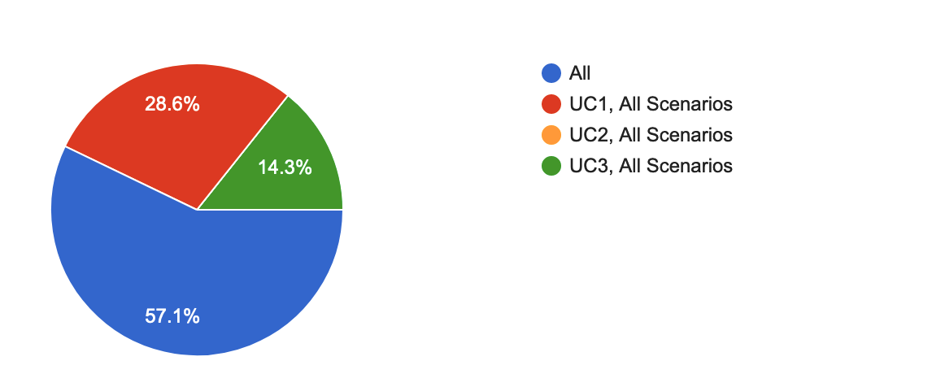
Figure 5. Use-case coverage over the interviewees.

Furthermore, on the other hand, the plot in Fig. 6 plots the most interesting parameter types reported by practitioners as useful in their own current practice as part of their practical activities in the context of the UC1-3 investigations.

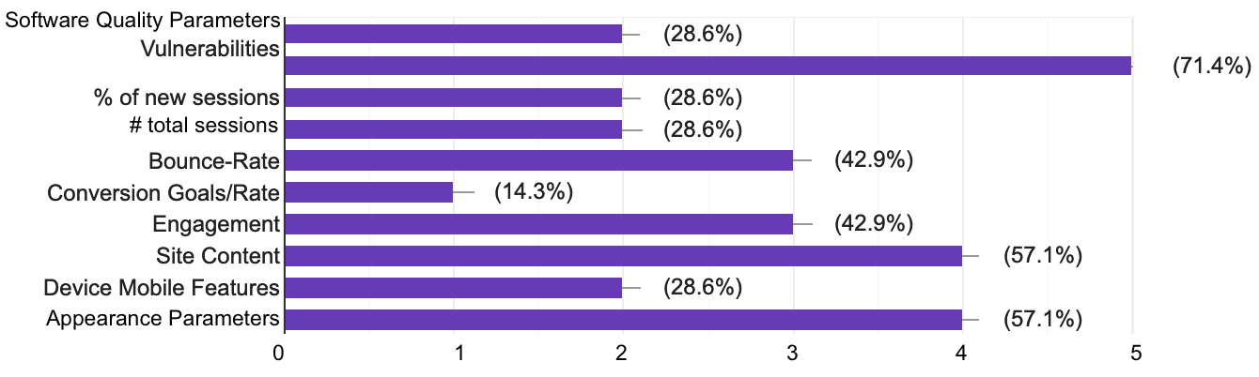
Figure 6. Most used parameters for ANITA UC investigation.

The parameters reported by the ANITA practitioners remark a striking similarity with the parameters reported in the state of the art (see D5.1). More specifically, (1) website appearance parameters & site content as well as (2) software vulnerabilities reported in the site (e.g., types of attacks enacted by site hosts or bots hosted therein) are among the most useful aspects being used by practitioners in action, followed by the site’s engagement metrics e.g., its bounce-rate, namely, the percentage of visitors to one specific site which bounce-back from visiting after viewing only one page.

Web-Survey Data Overview

Cyber-Threats Data

Results

Discussions and Implications

Use Cases ANITA Implications

General Implications for ANITA project

Module’s Implications for ANITA project

Conclusions

Closing the task and conclusion

Gap and Future Work

Bibliography.
[KAlpha] Krippendorff, K. (1980). Content Analysis: An Introduction to Methodology. Beverly Hills, CA: Sage Publications, Inc.

http://www.enlets.eu/
https://www.oasis-open.org/committees/tc_home.php?wg_abbrev=cti

